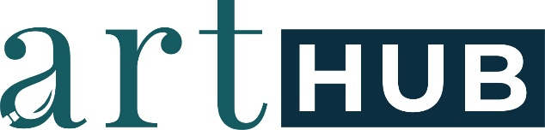

Terms & Conditions

This Contract is between the Artist and the Nashua Area Artists' Association (hereinafter “NAAA”) in exchange for mutual benefits shared by both parties, the parties agree to the Terms and Conditions as follows:

- I, the Artist, agree to allow the NAAA through its agent, ArtHub to sell my artwork for commission. I confirm that I am the sole creator and owner of the submitted artwork. I also confirm that the submitted artwork is not derived from the work of another artist and was not completed as part of an instructional class.

- I, the Artist, acknowledge that exhibition space is limited. Artwork will be displayed as space limitations allow. The artist will be contacted to pick up any work we are unable to display. Pickup, delivery and removal deadlines must be strictly adhered to. Work left beyond the pick-up date will be subject to a $5 per day holding fee. Work left 30 days beyond the pick-up date will be considered abandoned and will become the property of the NAAA. If such work is sold, I shall not be entitled to any of the proceeds of such sale.

- I, the Artist, reserve copyright, including all reproduction rights, except for photographs made to advertise and/or to memorialize the exhibition.

- I, the Artist, acknowledge that the “NAAA” through the ArtHub will make every effort to ensure the safety of the Artist's work and that the exhibition space is a public place and the safety of the artwork cannot be guaranteed. I, the Artist, am responsible and, therefore, may choose to insure my work for the length of the exhibition. I, the Artist, will not hold the NAAA liable for any loss or damage.

- To provide this opportunity for artists to display. To maintain the exhibit and the NAAA, there will be a commission of 30% for members and a commission of 40% for non-members. All artworks must be priced in dollar values only, no cents.

- I, the Artist, acknowledge understanding of the Eligibility, Entry Information, Entry Procedures, Artist's Responsibilities, and Fees and Commission as presented to me. I acknowledge reading and understanding the Policy and Guidelines for Displaying at the exhibit space provided by the NAAA and will abide by said Guidelines and Policies.

By affixing my signature below, as a condition of Exhibiting with the NAAA, I acknowledge and agree to all Terms and Conditions above.

Signature of Artist Date

