
Kids and Teens Art Show Application

REQUIREMENTS:
A) Each child or teen may exhibit one piece. Each participant may enter one piece of artwork in this exhibit.
B) Artwork may be 2D Oils, Acrylics, Pastels, Drawing, Watercolor, Photography, Digital Art, or mixed-media, etc. No AI (Artificial Intelligence) enhanced are allowed.
C) The artworks must be ORIGINAL works done by the students themselves.
D) The artwork cannot have been previously shown at any Nashua Area Arts Association (NAAA) sponsored event.
E) Artwork must be matted or framed with tag (see below) on back of work, listing title, medium, name of artist and age. The artwork must be ready to hang with proper wire hangers on the back.
NOTE: Entries will not be accepted if the art is not ready for hanging.
NO ENTRY FEE FOR CHILDREN OR TEENS

Artist Information
Student’s Name: __________________________________________________________________ Age: ________________
Student’s Address: ________________________________________________________________________________________
Parent’s Name: ___________________________________________________________________________________________
Email:____________________________________________________________________Phone:_________________________
Title of Artwork:______________________________________________Medium:_____________________________________
By signing this agreement, made on the________ day of ________________, 2026, I acknowledge and agree to the following conditions with regards to participating in the ArtHub Kids and Teen Art Show.

I hereby fully and finally release and will not hold the Nashua Area Artists’ Association, or anyone involved with the project responsible for any damage or loss to any property and artwork belonging to me.

I hereby give the Nashua Area Artists’ Association & the ArtHub permission to publish on the photographs and/or images of artwork I have created. I hereby waive the opportunity or right to inspect or approve the finished photograph or image. I do hereby release Nashua Area Artists’ Association & the ArtHub from any and all rights, claims, demands, actions or suits which I may or can have against them on account of the use of publication of said photographs or images.

I certify that the piece of art submitted by the above named student is an original creation and not a copy of published art or photography.

Student’s Signature: |  | Date:
(If 18 years of age)

Parent’s Signature: |  | Date:
(If under 18 years of age)

Please note that student artist must be present at award ceremony to accept ribbon/prize.
All art MUST be collected after the ceremony.

Event Timeline:
- Art and Application Drop-off hours: 10:00am - 11:15am at the ArtHub located at 98 Main St Nashua, NH 03060
- Judging: 12pm - 1:00pm
- Awards Ceremony: 3:00 pm

AWARDS: Winning works receive ribbons and prizes after judging. Awards are presented starting at 3:00 pm. on the day of the event. Please be there!

First place and Best of Show will be displayed in ArtHub for public viewing for one month. Any artwork not being displayed need to be picked up after 3pm the same day.

JUDGING Details: Ribbons and awards are given in four age groups:
Ages 6 – 9 Ages 10 – 12 Ages 13 – 15 Ages 16 – 18

FOR MORE INFORMATION PLEASE CONTACT:
Jayson Gleneck or Shelly Toomey at NaaaEastShow@gmail.com
NAAA Website: https://www.nashuaarts.org

This event is proudly sponsored by:
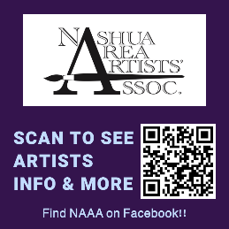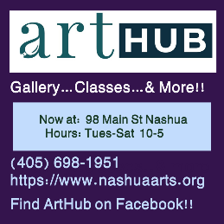

TAG YOUR ART!
(Affix to the BACK of your artwork)

-----------------------------------------------------------------------------------------------------------------------
Student’s Name: ____________________________________________________ Age: ________________

Title of Artwork:______________________________________________Medium:_____________________________________

ID TAG_________________________________________(for internal use only)

-----------------------------------------------------------------------------------------------------------------------

